Our [dataset](https://docs.google.com/spreadsheets/d/1G9sTrkfUPrzMDJSRKTBgWKO7IJZsp6j1eKi5to4tIoA/edit?usp=sharing) consists of two sheets. Each row in the “Entries” sheet represents either an event (the presence of an author in Italy) or a reference to Italy or Italian culture by an author. The “Multimedia” sheet consists of information about the multimedia artifacts that you will find.

You can select which sheet you want to operate on by clicking on the tabs at the bottom of your browser window. The tab in white is the one you are currently editing. For instance, in the image below, I am working on the Multimedia tab.

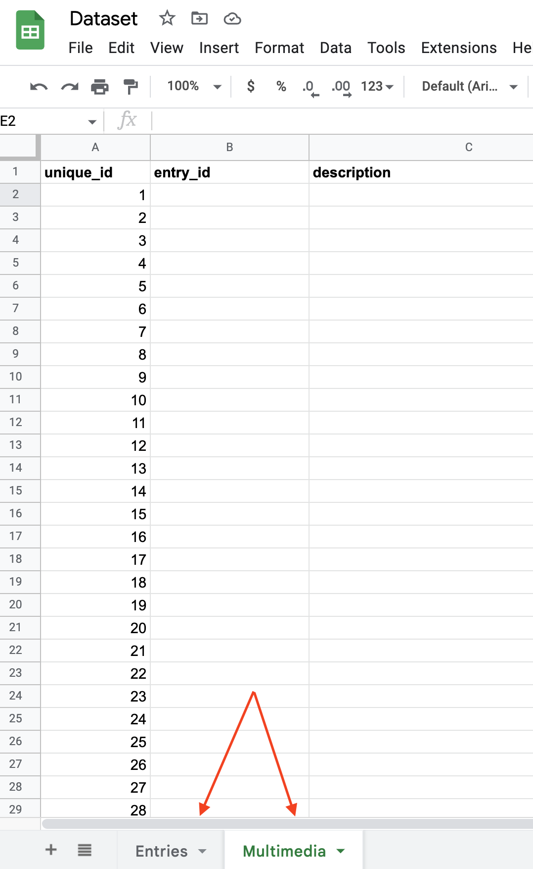

# [Entries](https://docs.google.com/spreadsheets/d/1G9sTrkfUPrzMDJSRKTBgWKO7IJZsp6j1eKi5to4tIoA/edit?usp=sharing)

**unique_Id:** Please ignore this field for now.

**author:** Write the name of the author(s) whose presence in Italy or representation of Italy you found.

* Make plans with your team members to look at different archival sources and primary texts.
* At this stage, your primary focus should be on all the authors that have been assigned to your group (not just the individual author of your preference).
* If you stumble upon some information that doesn’t concern the authors assigned to your group but might be of interest to your classmates (or authors associated with the Beat Generation that nobody chose!), you are expected to show camaraderie and add that information to the spreadsheet as well.
* If the event concerns more than one author, add a new line for each author.

**location:** Allyour entries must be consistent with the following format:

* Name of Place, Address, Town, Province (solo se la città non fa provincia).
* Be as specific as your source allows you to be. For instance:
  + Centro di produzione Rai di via Teulada, Via Teulada 66, Roma
  + Canal Grande, Venezia
  + Spoleto, PG
* If the name of a place is provided, but not an address, do your best to identify what the address is, if you are not certain about your findings, please write it in the “Notes” column.

**date:**

* If your entry concerns a literary text, use the date of publication.
* If your entry concerns an event, be as specific as your source allows you to be.
* All your entries must be consistent with the following format:
  + Month Day, Year
  + For instance:
    - September 30, 2022 (if the precise date is available)
    - September 2022 (if only month/year are available)
    - 2022 (if only the year is available)
    - September 5-20, 2022 or September 30-October 20, 2022 (for date ranges)
    - Mid-2020s

**kind:** Depending on the nature of the entry, select among the following classes.

* If your entry concerns a literary text, select among the following classes from the taxonomy suggested by Barbara Piatti and used in the development of A Literary Atlas of Europe:
* **Setting:** the location in which the action represented in the narrative occurred;
* **Zone of action:** the location where the action takes place, used for narratives that combine several settings;
* **Projected spaces and places:** locations that characters dream about, desire, or remember;
* **Topographical markers:** places mentioned in a text but don’t play a significant role as settings;
* **Paths and routes:** movement of characters between different locations;
* If your entry concerns an event, select among the following classes:
* **Visited**
* **Interview**
* **Other:** Anything that is not described in the above. Please leave comments in the “Notes” column

Let’s discuss together what other classes could be useful for our project!

**quote**: Only use if your entry concerns a literary text.

* Copy/paste or transcribe the passage where the location is mentioned in this field.
* If the quote is too extensive or the place appears multiple times in the text, just report the most significant segment(s).

**event_name**: If your entry concerns a visit to Italy, or a specific event whose name can be identified, write the name of the event here (E.g. “Spoleto Festival of Two Worlds”). If the event has no name, try and come up with a description of the event (E.g. “Meeting with Salvatore Quasimodo”)

**source**: Cite the text or source where you found your data using [Chicago Style](https://www.stu.edu/Portals/library/HowTo/docs/ChicagoNotesandBib2013.pdf). If you have included the entire citation for a text in a previous entry, in the next one you can use a shortened version. Make sure you include the page numbers for each of the passages (e.g. “Page 2” or “Page 2-4” or “Page 2,5,7”) where the description or action takes place. E.g.:

* Full entry: Kerouac, Jack. 1957. *On the Road*. New York: Viking Press. Pp. 4-7.
* Shortened: Kerouac, *On the Road*. Pp. 4-7.

If you’re quoting a secondary source, try and retrieve the primary source for the information that informs your entry!

**resources:** Identify multimedia resources that illustrate/relate to each entry. Not every entry will have a resource attached, but some will. Please refer to the existing ones for examples.   
When you identify the resource, please add the link in the “resources” column. If the entry has more than one resource, please divide them with a space and semi-coma; e.g. “Link 1 ; Link 2). If the resource lives on your computer, please upload it [in our Multimedia folder](https://drive.google.com/drive/folders/1SKZBjxJx1SIh7-CSXYTBybB-XwEakzJ9) and write the name of the file in the column.

**contributor**: Write (or select from the dropdown menu) your last name.

**Please note:**

* Don’t forget that we are especially interested in the postwar period (very roughly: between 1949 and 1972), so focus your research efforts accordingly.
* Make sure to be consistent while compiling our dataset.
* Do not work on any row that has been filled out by a colleague; even if only one column contains data, start compiling your entry in the following row.
* Familiarize with [the shortcuts for Google Sheets](https://support.google.com/docs/answer/181110?hl=en&co=GENIE.Platform%3DDesktop) to optimize your workflow.
* When Copy-Pasting, make sure you use “Paste without Style” by using the shortcut Command + Shift + V.

# [Multimedia](https://docs.google.com/spreadsheets/d/1G9sTrkfUPrzMDJSRKTBgWKO7IJZsp6j1eKi5to4tIoA/edit#gid=2125120006)

Our story map will include a number of multimedia files (video, images, audio recordings, etc.) to aid our storytelling efforts. When you find images, videos, or recordings that relate to one of the events you reported in the “Entries” sheet, you will report them on the “Multimedia” sheet.

**unique_Id:** Please ignore this field for now.

**entry_id:** Report the unique_id of the entry to which the item pertains.

**description:** Describe what the item is/represent.

**source:** report the URL where you found the item.

**file_name:** if the file can be downloaded, save it [on our shared Google Drive](https://drive.google.com/drive/folders/1SKZBjxJx1SIh7-CSXYTBybB-XwEakzJ9?usp=share_link) and report the name of the file in this field.

**Please note:**

* At this stage, feel free to be as expansive as you wish in collecting your material—treat this spreadsheet is more of a wish-list than a selection.
* The process might feel a bit tedious at first, but structuring our data will considerably save us time as we work towards developing our map.